**REQUISITION SLIP**

* **TO START,  
  1.) Menu**

Transactions

Menu

Requisition Slip

**2.) Transactions  
3.) Requisition Slip**

2 1*1*

1 1*1*

3 1*1*

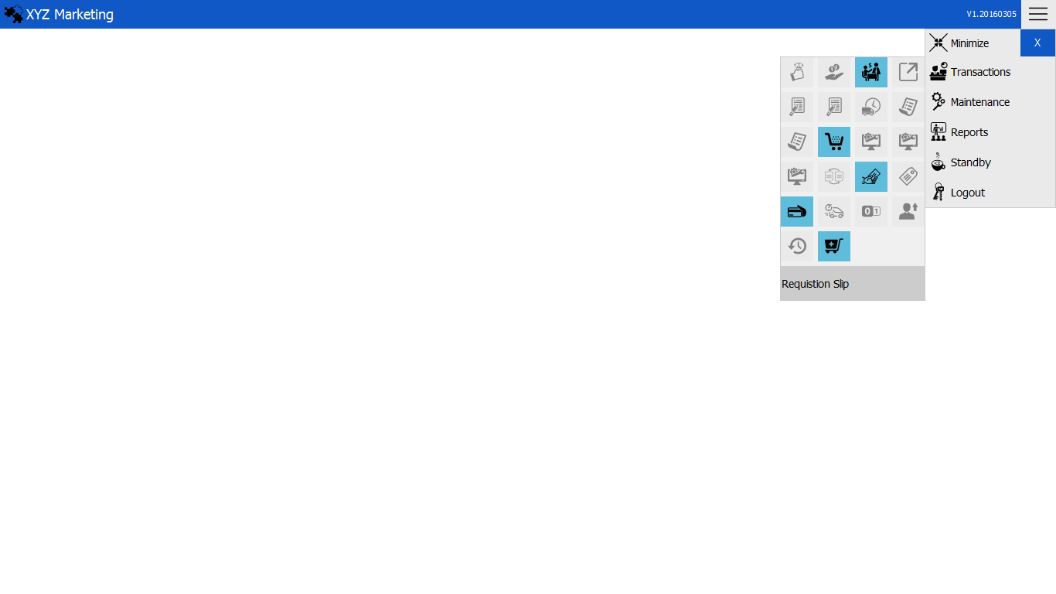

Location

Date

Request type

Requested by

3 1*1*

4 1*1*

1 1*1*

2 1*1*

Department

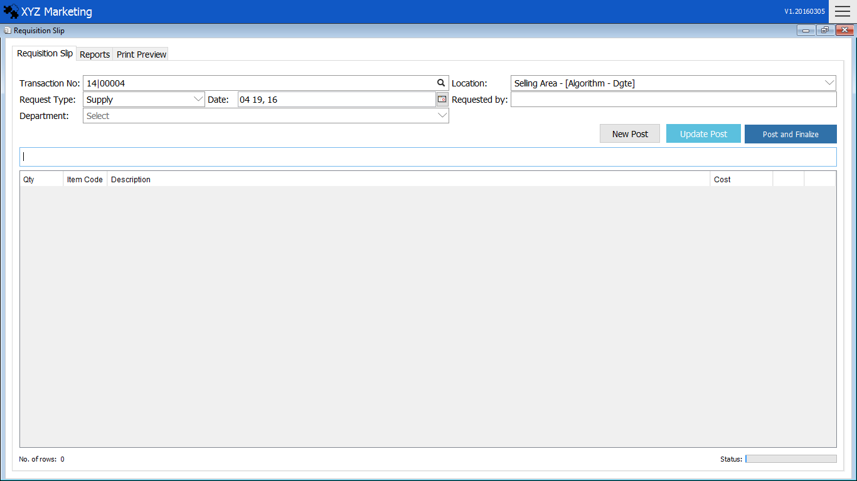

7 1*1*

6 1*1*

5 1*1*

Post and Finalize

Search Box

**1.) Input Request type**



Input the Request type.

**2.) Input the date of request**



Input the date when you request

Input the department of the

**3.) Select the Location**

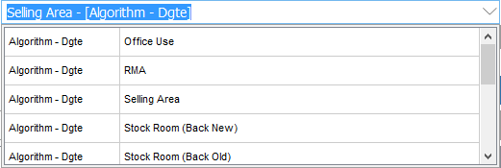

A default location will be displayed in the input box. Choose the location which the delivered item come from.

**4.) Input the name who requested**



Input the name that who requested.

**5.) Input the department**



Input the department of the one who request

**6.) Search item, Add item and update**

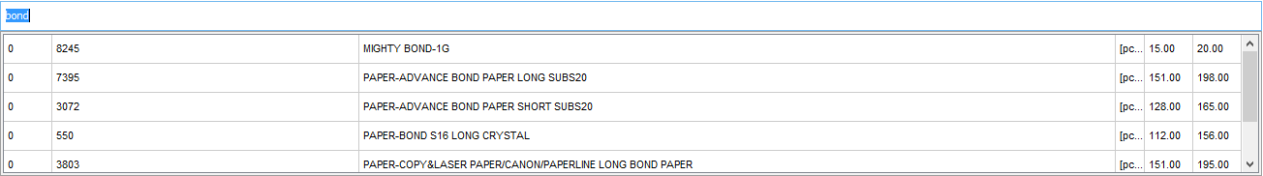

We can search item by using the,   
a.) Item Code  
b.) Description

Cost

Default unit of measure (UOM)

Description

Number of item available

Item

**6.1) Input Quantity & Serial Number**

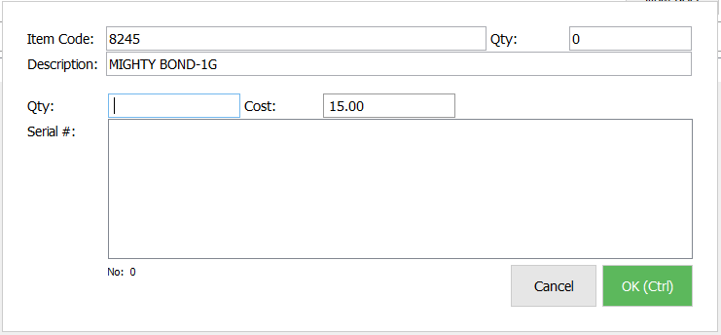

a.)Input the Quantity  
b.)Input item’s serial # references  
c.)Click ok to continue

**6.2) Update & Delete Item in request**



Delete

Update

**7.) Post and Finalize**



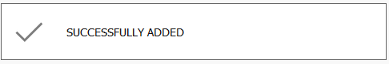

After filling all the details and item request, click “Post and Finalize” button .

A message will appear once the transaction is posted.

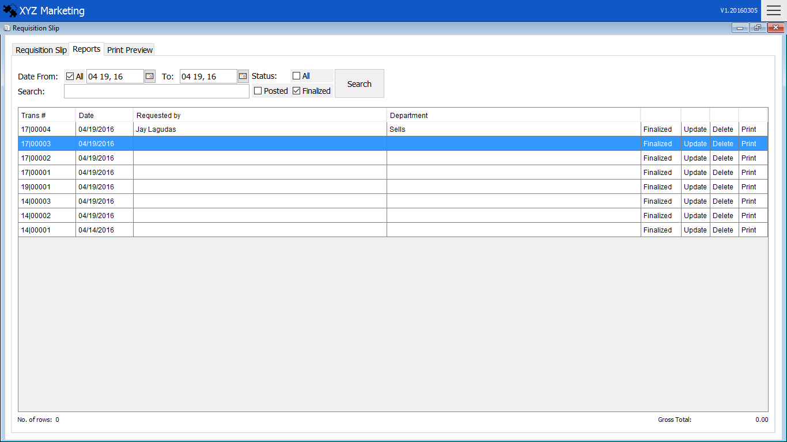**REPORTS**

Search Filters

Status

Print

List of Requests

Reports

Reports show the list of requests.

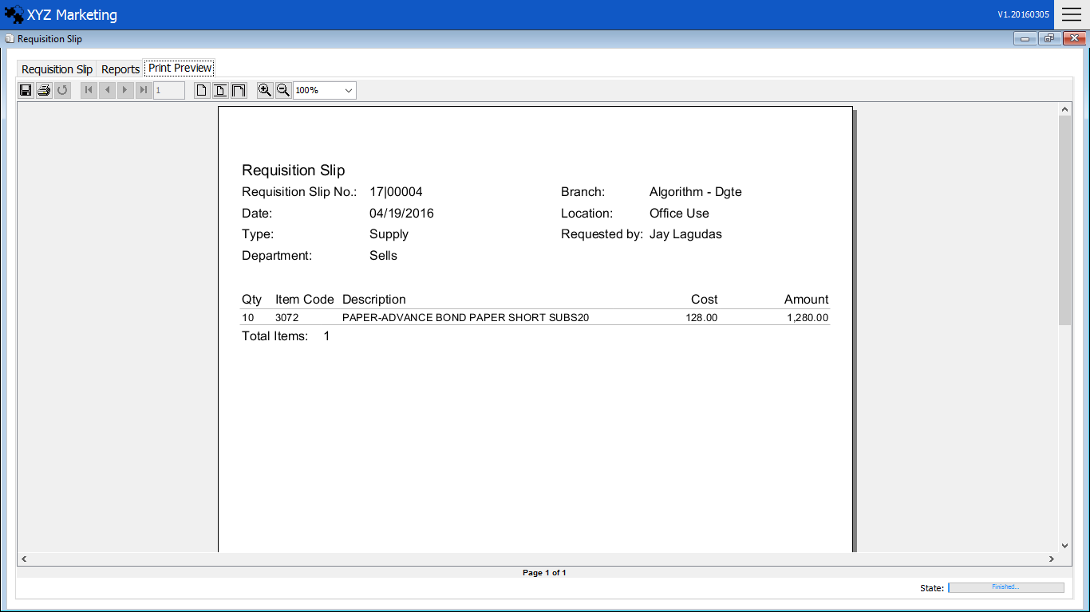**PRIT PREVIEW**

Print Preview shows the details of the request.